

**SOEN 6841  
SOFTWARE PROJECT MANAGEMENT**

**Title of the project:** Collecting narratives on self-managing health care experiences.

**Sprint 1 Demo by Team G**

|  |  |
| --- | --- |
| ***Presenter Name*** | ***Presenter ID*** |
| *Nivetha Ravi* | *40085910* |
| *Hina Masood Ahmed* | *40076287* |
| *Sahana Shankar* | *40092026* |
| *Shruthi Kondapura Venkataiah* | *40091427* |
| *Anusha Keralapura Thandavamurthy* | *40102962* |
| *Surya Prakash Govindaraju* | *40085527* |

1. **User Characteristics: Persona**

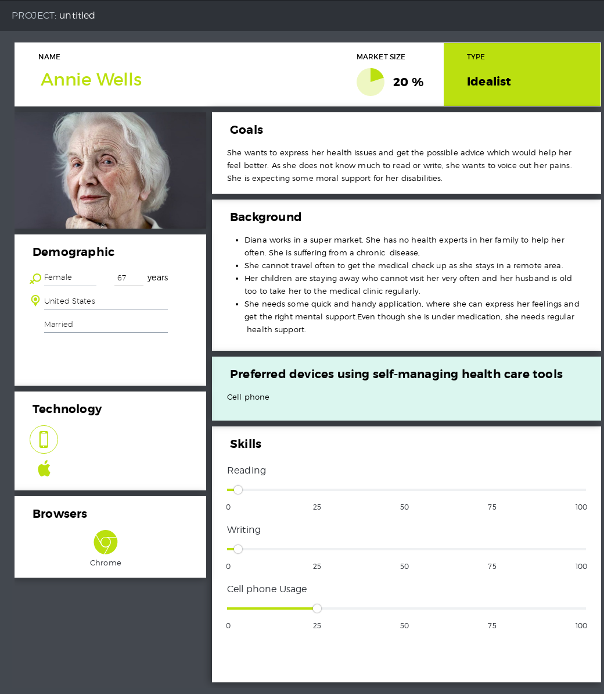

1. **Set of Task Performed: Narrated Story**

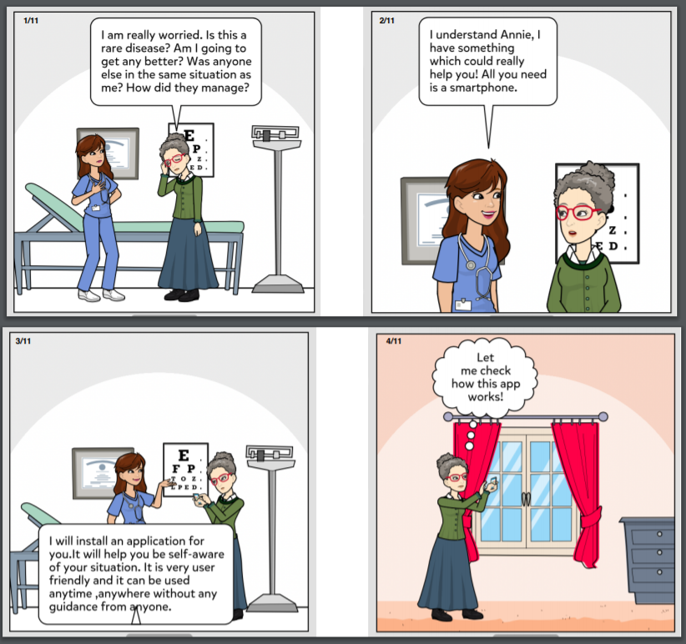

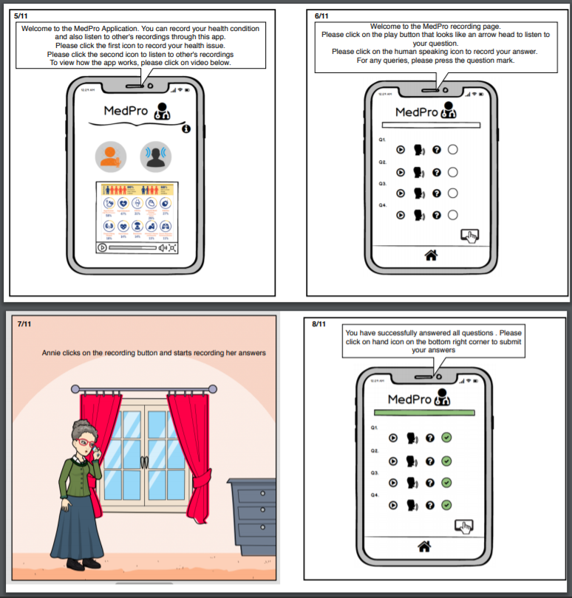

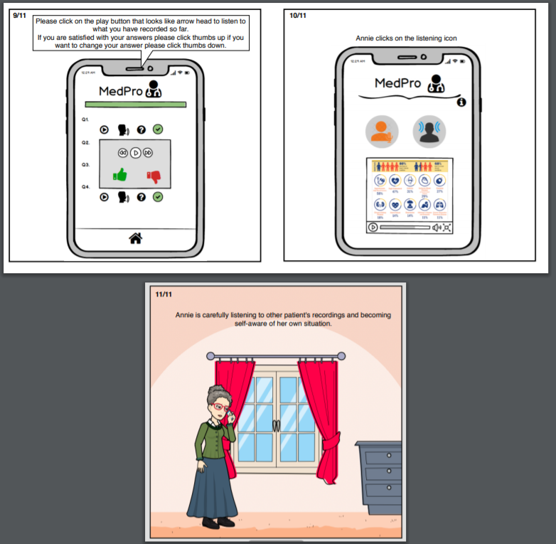

1. **Context of Use**

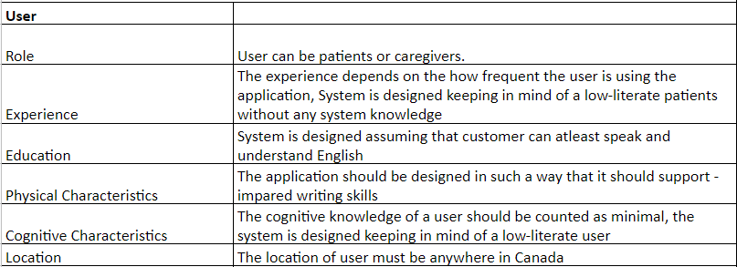

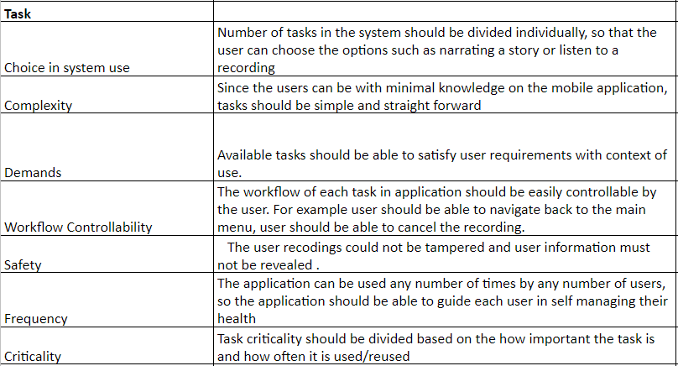

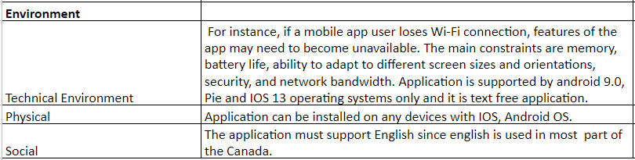

1. **Objectives**

* Making an application accessible to a broader community.
* Application must be text free and must support low literate people.
* Goal is to collect narrative story about health condition.
* Collection of data by asking few sets of predefined questions.
* Text-free by using voice for feedback and navigation, and symbols for the buttons which functionality should be easy to understand or figure out by users